WHY YOU NEED YOUR PROTEIN

I can’t emphasise enough the importance of eating enough protein in your diet.
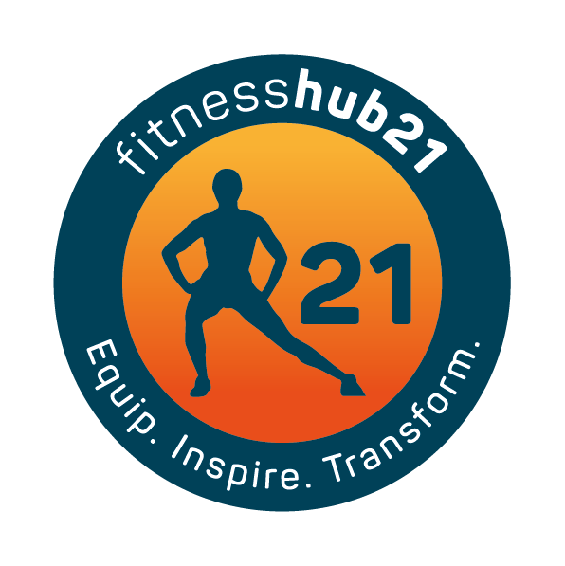
Protein is essential for optimal health and making sure your eating enough can also help you lose weight and recover faster from training.
Protein is made up of Amino acids – they have a variety of functions that are essential to us and our health.
Protein consists of Essential amino acids and non essential amino acids. The essential ones can only come from the diet as we can’t make them ourselves.
Protein sources that have all essential amino acids are called complete proteins.
These are usually found in animal products but are also found from vegetable and grain sources
They are important for collagen and elastin, all enzyme function, hormomes, immune function, acid base balance, fluid balance and energy balance
They constitute a large part of muscles, hair, skin, teeth and bones
Below are 2 slides on the benefits of protein and where you can find complete proteins

