OBSTACLES TO TRAINING IN WOMEN OVER 50

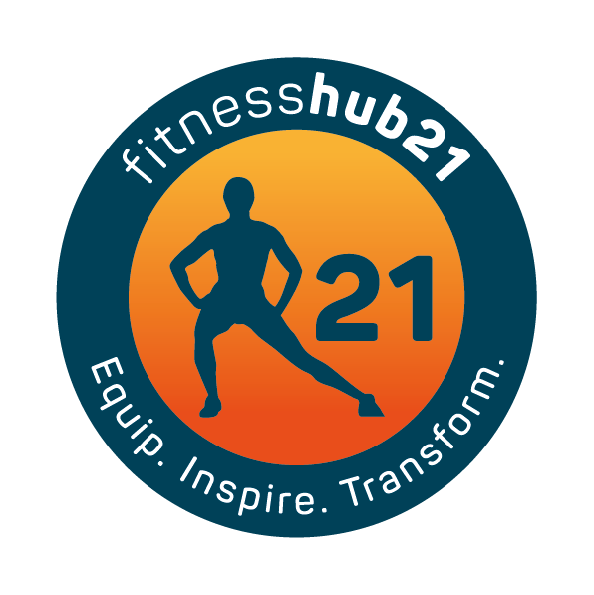
Starting out with a desire to get fitter and stronger can be daunting at any age, but even more so as you age. There is a need for all women to take up strength training; especially for women over 50. The health benefits are massive – increased bone strength to prevent osteoporosis, increased strength to preserve muscle mass, blood sugar regulation and increased energy expenditure

But where do you start? There are many obstacles standing in your way especially if you haven’t spent the past 10-20 years in the gym or with a personal trainer.

- Feeling out of place and self conscious
Problem – Most gyms are very intimidating to say the least and when you are over 50 it may seem like a strange place. The weights area is bombarded with men and on top of that you don’t know where to start.

Solution – Find a place where you feel comfortable, private personal training gyms may work best as there are less members and all sessions are with a coach.
You need to feel welcomed and at home, and also given the right training to suit your needs. Look for a gym where the culture and environment suit you.

- I don’t want to get hurt
Problem – this is a legitimate concern for anyone starting out. Your risk of injury will increase when you don’t know what your doing.

Solution – If you have health conditions speak to your doctor first to see if you are ready to start training. Sign up for some session with a personal trainer who can teach you how to move, how to train and how to get moving better. Technique is king when it comes to building strength, followed by consistency and progressing the program when you need to.

- Having trouble finding time
Problem – The kids may have grown and maybe you thought that once you get to 50 you would have more time but that hasn’t seemed to be the case. Years of inactivity or not having time to yourself is a very real problem and the years have taken their toll on your health. There is never a perfect time to start working on you and finding time can be hard, but not impossible.

Solution – Find a place to train that has a flexible schedule, start every week by putting in time to train in your diary. Schedule it like you would a dentist appointment and stay accountable to that commitment. Remember you will benefit from your training and you are only letting yourself down when you fail to start. Exercise makes you feel better about yourself, it will boost your energy and time invested in your health will only benefit you and make more enjoyable.

- Believing that all you need is cardio training
Problem – We have been led to believe that older people need more cardio and less strength training. As more research is done it is becoming clear that women over 50 need more weight training than cardio. While sitting on a bike for 40 minutes will help you get fitter; strength training will help improve all over well-being and set you up to be stronger, fitter and mentally sharper as you age.
Solution – Find a place that specialises in personal training or a coach at a gym that understands what you need. They should be able to lead and guide you in the right direction and set you up for great results that will help you get what you need from training.
Whatever the obstacle to training the pros far outweigh the cons especially when it comes to your health. You can’t ignore the fact that regular training will lead to greater health and over all wellbeing.
So get moving, see what is available to you locally and get started.

