HOW TO LOSE WEIGHT AND KEEP IT OFF
When it comes to losing weight, gaining muscle or increasing fitness its easy to be confused about how to go about it and what really works
Fitness Hub 21 aims to focus on the basics and look to the long term goal for weight loss and health
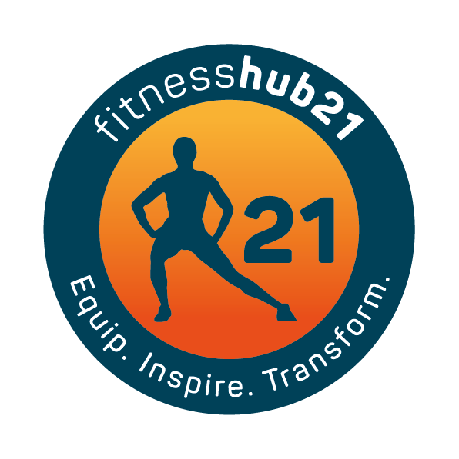
Don’t go on a diet – while being in a calorie deficit is essential for fat loss losing weight is just more than counting calories. You must change your mindset and adopt a new way of thinking about it. Ask yourself can you maintain this for the rest of your life? And with most diets the answer is NO. You need to eat real food that adds to your health and not be so restrictive that you are miserable.
Get more sleep – Better quality and quantity is vital for fat loss and overall health
Look at portion size – Do you eat too much per meal? Even though it’s healthy you may still be eating too much. Swap out your plate for a bowl instead to help you eat smaller portions.
Reduce sugars and starches – if you want to lose weight you may need to reduce your consumption of sugar (food and drink) and processed foods. Opt for more protein, vegetables and healthy fats and aim to enjoy these other things a couple of times a week
Eat more protein – it will make you feel fuller for longer and aids in improving your health and strength
Eat more vegetables – Try replacing some of the grains you eat with more veg, it will leave you more satisfied after a meal and increase your fibre intake as well as vital nutrients your body needs
Eat good fats – Olive oil, avocados, coconut oil nuts and seeds. These are essential for your body and have many health benefits
Drink more water – Hydration is important for optimal health. Carry a water bottle at all times and make water more palatable by adding lemon, lime or orange to your water which will encourage you to drink more
Train weights and interval training – Train smarter not longer or harder than you need to. Weight training will help you lose weight but also give you more strength and better shape than cardio alone
Eat a balance of 80/20 – 80% of your meals are on point and 20% is whatever you like. This will ensure long term results as its easier to stick to

