FATS – WHY WE NEED THEM AND THE DIFFERENT TYPES
Fat gets a bad wrap when it comes to weight loss and health.
It is quickly passed off as bad for you and the reason you have high cholesterol or are overweight.
Fat is actually essential to the diet
We need it to function
We need it to lose weight
We need it for optimal health
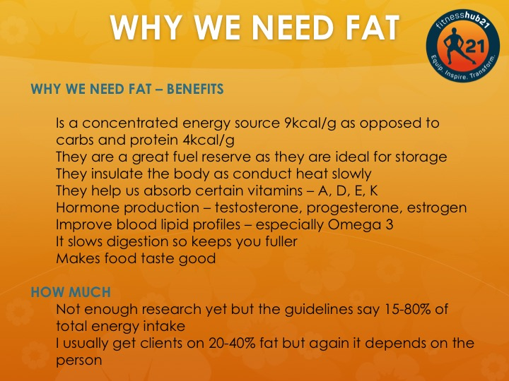

Now we know the benefits of fat and how much you need
Here are the main types of fats you eat on a daily basis.
Although saturated fat gets slated as bad you can actually eat it and still be healthy.
It all comes down to balance.
You need polyunsaturated fats as they are essential to the body and need to come from the food we eat.
Eat a variety of different fats
Avoid Trans fats as no good can come from eating them
Increase your intake of Omega 3
Make sure you eat at least 15% of your calories from fat for optimal health.

