CAN YOU HAVE YOUR CAKE AND EAT IT !!

Over the years my approach to weight loss has changed, having competed in physique comps for 5 years my dieting approach was quite rigid and I only gave advice based off my own experience.

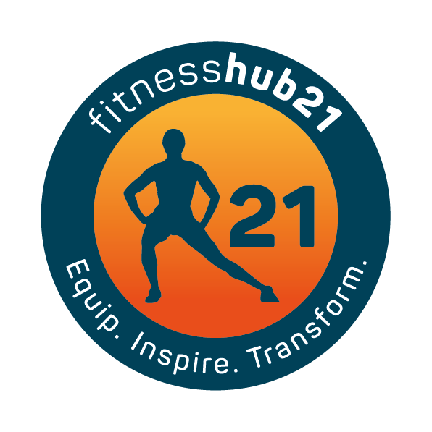
What I have learned these past few years is that the bar I set for members was to high. My focus and drive was too much and they needed a more relaxed approach to healthy eating and training so that they could achieve results and stay the path.
I realized that you don’t have to be super strict and cut out everything you love in order to get results.

In saying that if you want great results then the sacrifice has to reflect that, you can’t put in minimal effort with training and a lousy diet and expect a massive transformation.

This year alone many of our members have achieved a balance between training hard, healthy eating and enjoying meals out. They have lost weight, increased their fitness and regained their health without having to go cut out everything they enjoy – in other words they have found a way to have their cake and eat it.

We encourage hard work and we encourage a relaxed approach to diet, but the more you train the more you can eat/drink. It’s not the normal approach but it’s one we have found works in giving members freedom to choose and to enjoy life. I

t’s about finding a balance that works for you, that ultimately leads to you getting the results your after without having to go down the restrictive/fad diet road.

Weight loss isn’t complicated
Just do the basics well (link to basics blog)
You don’t have to go on a severely restricted diet
You don’t have to become a recluse – afraid to go out in case that one meal makes you put all the weight on again.
You can have a social life – you just have to make sure you put in the hours of training and healthy eating in and around those areas of your life.
You can eat ice cream and still lose weight – if its balanced and adjusted for in your meals.

For more information on our 30 day Kick Start contact us on hello@fitnesshub21.com

