BREAKING THE MOULD – WHY WOMEN SHOULD ADD WEIGHTS TO THEIR TRAINING

Weight training has so many benefits especially for women. In my experience as a trainer for over 10 years, this is what I see happens when my new female clients start doing resistance training
- They become stronger and more confident
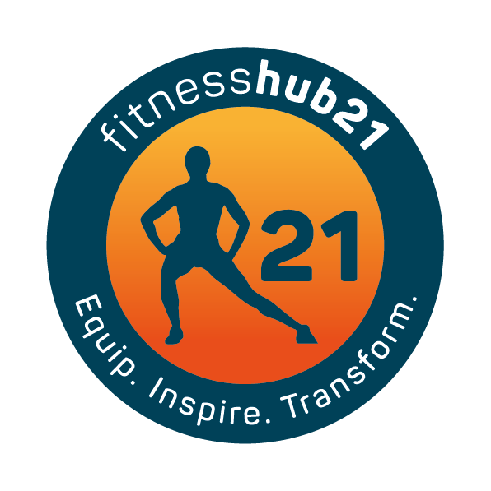
- They start to find muscles they never knew existed and tune into themselves a bit more
- Their Posture improves
- They lose weight
- Their shape starts to change and they become more toned
- They are constantly surprising themselves with what they can do in training – this applies to anything from doing push ups, pulling a sled and lifting barbells off the ground.
- Under the right supervision and correct training my clients are amazed at what their bodies can do. More often than not my female clients are stronger than they think!
- They are more flexible and have less aches and pains – A great 10-15 min movement and stretch preparation before training will help increase flexibility and reinforce good technique when training
- Improved quality of life, the ability to get through the day with energy left to enjoy other things in life

The common myth around why women avoid weight training is that they don’t want to get too big or look bulky, therefore they opt for cardio training instead as a way of trying to lose weight. There are a growing number of women who are now reaping the benefits of switching to resistance training.
Research suggests weight training can slow down the aging process, helps to build muscle mass, can help in blood sugar regulation, helps prevent osteoporosis and increases energy expenditure.
What stops women I train from starting a weight/circuit program is –
- Feelings of looking silly and out of place in the gym
- Not knowing where to start
- Not knowing what they need to do
- Not having someone there to show them
- Having to do it alone

At Fitness Hub 21 our clients don’t necessarily have a history of training, they simply want to be fit and healthy as they age, have a stronger core, and in some cases lose weight.
Our gym provides the ideal environment for anyone to keep fit – it’s boutique, private and welcoming. What’s more is that the training sessions are fun!
We support each other and share in our individual improvements.

